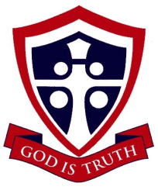

KINGSWAY CHRISTIAN COLLEGE
Year 12 ATAR Physics 2017
Task 7
In class response to Quantum Theory article
Name _______________________________________________

Date due: Wednesday, 02 August 2017
Time allowed 40 minutes
 | Available mark | Student mark
1 | 2
2 | 2
3 | 2
4 | 2
5 | 5
6 | 4
7 | 4
8 | 19
Total marks | 40
% | 100

NORTHERN LIGHTS
The northern lights could be mistaken for an iridescent green mist until they dance across the sky, dipping and pirouetting, swirling like a tornado, or hanging like curtains rippling in breeze.
The Sun powers the performance via a stream of electrons and protons known as the solar wind that buffets atoms in the Earth’s atmosphere, causing them to release photons of light. The reason for the green colour is twofold. At an altitude of between 100 and 200 kilometres, nitrogen molecules are outnumbered by oxygen atoms, which are split from their molecular for by ultraviolet light. When buffeted by the solar wind, oxygen atoms glow green, a colour to which our eyes are more sensitive than the blue-violet glow of nitrogen molecules.
This dance was performed in Finish Lapland, just inside the Arctic Circle.

HALO
The fierce solar wind bumps other charged particles trapped in Earth’s magnetic field and sends them racing along the magnetic field lines to both poles. At the North Pole the display goes by the name aurora borealis: at the South Pole it’s the aurora australis.
The solar wind normally blows at around 400 km.s⁻¹ but explosions on the Sun’s surface known as coronal mass ejections create blizzards of 1000 km.s⁻¹ and dramatic auroras. On 11 September 2005, NASA’s IMAGE satellite captured a brilliant aurora australis created by one such storm.

JUPITER
The best place in the solar system to see auroras is Jupiter where they are thousands of times brighter than those on Earth.
Here Jupiter’s auroras are captured by NASA’s Chandra X-ray space telescope. The Image is overlaid on a Hubble photograph of the gas giant.
Unlike Earth’s intermittent displays, Jupiter’s aurora permanently lights up its skies because, beside the Sun, the moon Io gets into the act. Io’s volcanic eruptions spit jets of charged particles into space. They are captured by Jupiter’s magnetic field and catapulted toward the planet’s poles to create a never-ending show.

SATURN
The Cassini space probe allowed us to see Saturn’s brilliant aurora.
Just as on Earth, it flares brightest when buffeted by solar storms. Cassini captured this powerful aurora 1000 kilometres above the cloud tops around Saturn’s South Pole.
Earth’s atmosphere is rich in oxygen and nitrogen but Saturn’s is mainly composed of hydrogen, which gives off strong ultra-violet emissions when excited. But the excited hydrogen does give off a little visible light too. Cassini’s spectrometers captured some of this light in this image. The green colouring is artificial. If it were possible to stand at Saturn’s poles you’d see faint pink-red ripples dancing across the sky.
From an article in COSMOS Issue 68 April-May 2016.
The emission spectra of the elements Nitrogen, Oxygen and Hydrogen are also given below.
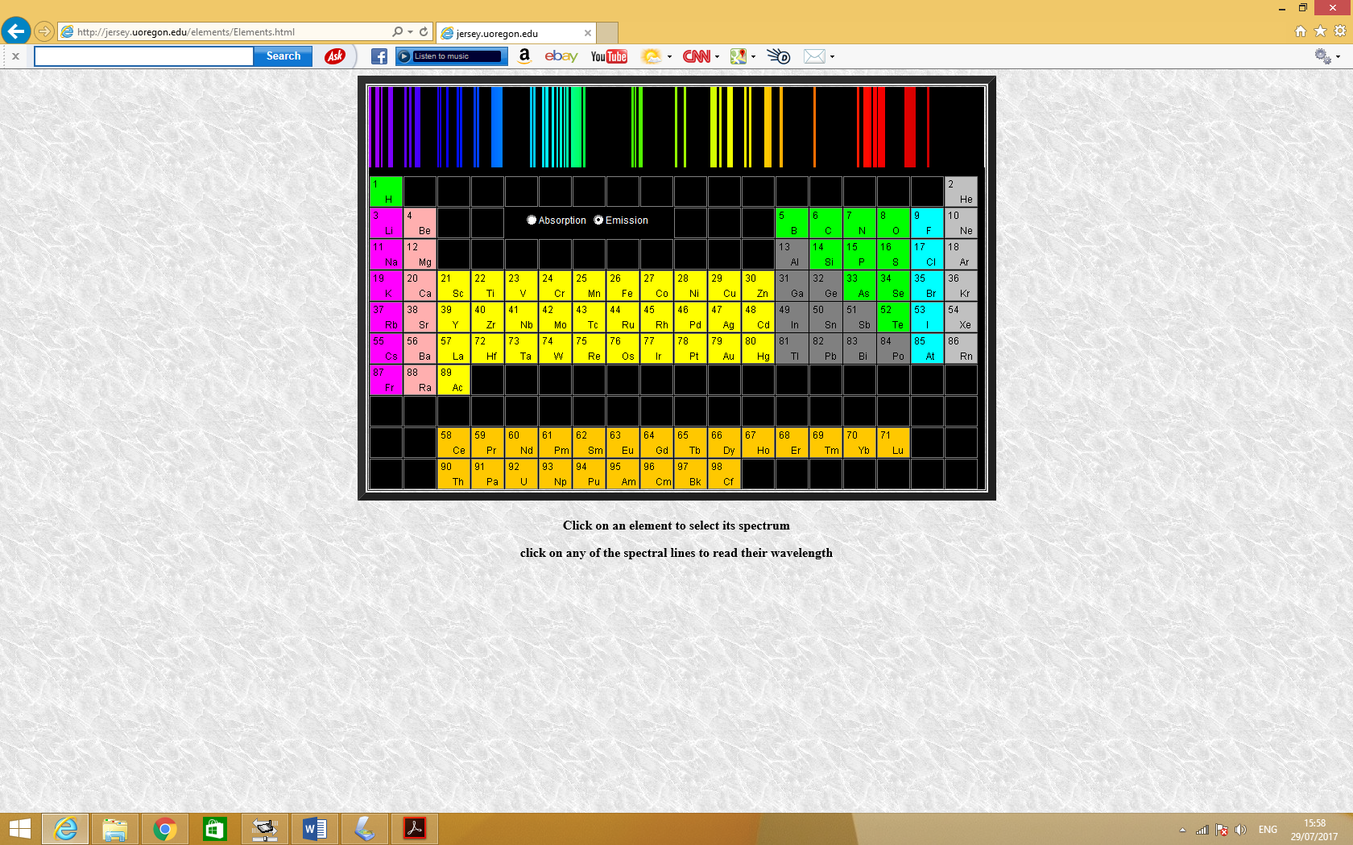
Emission Spectrum of Nitrogen
400nm 500nm 600nm 700nm

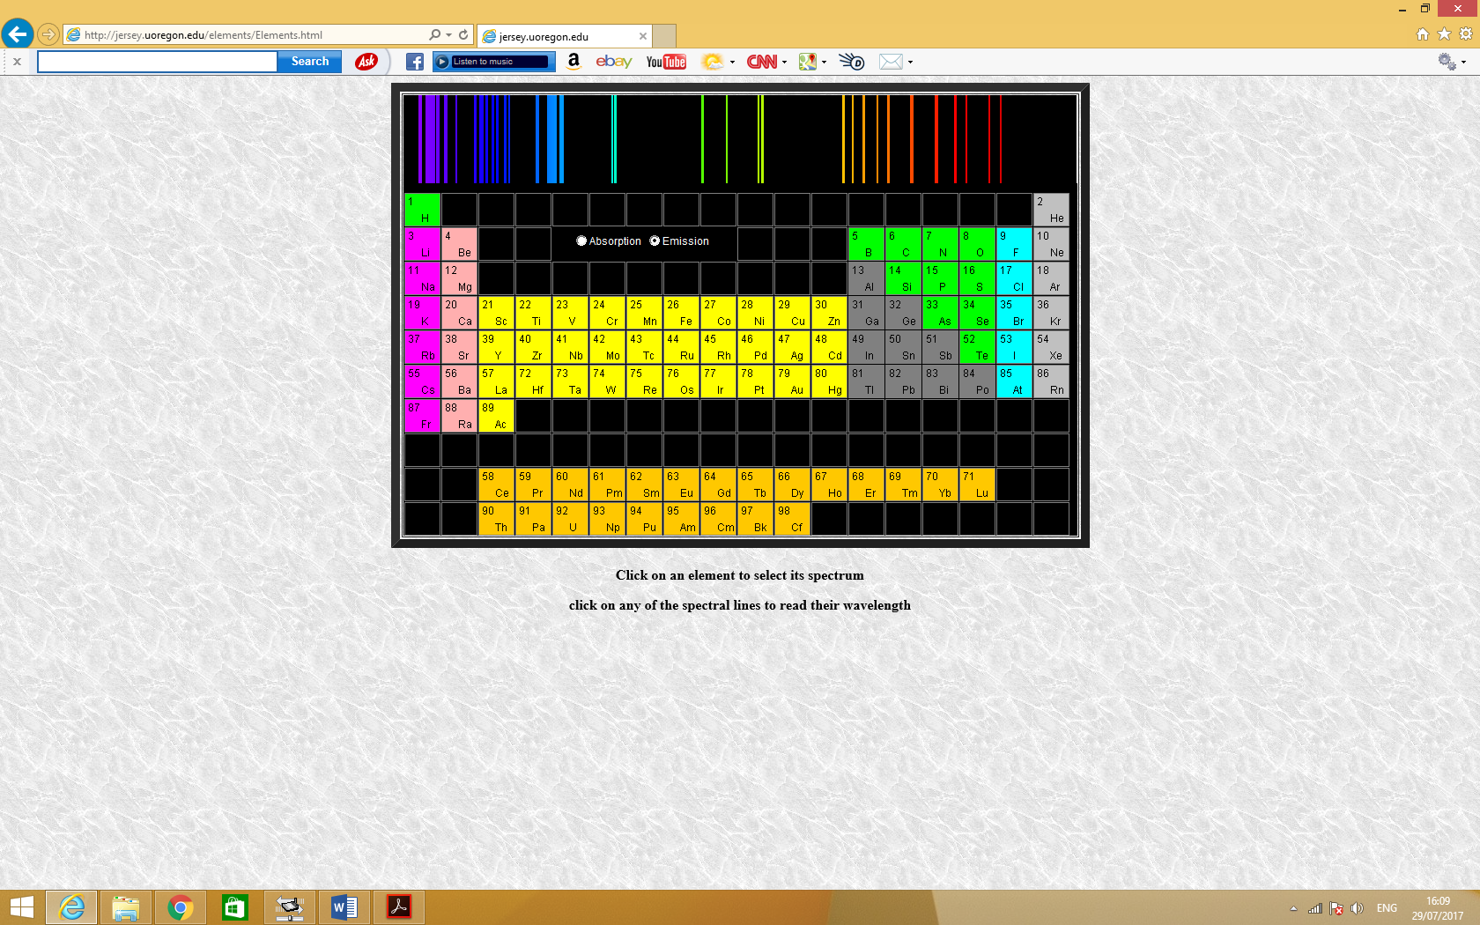
Emission Spectrum of Oxygen
400nm 500nm 600nm 700nm

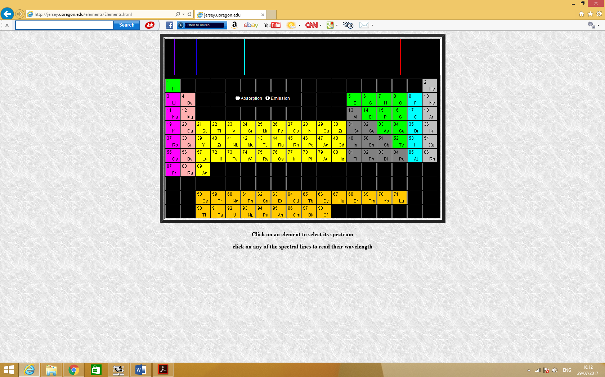
400nm 500nm 600nm 700nm
Emission Spectrum of Hydrogen

1. What charged particles are contained in the solar wind? [2]

2. At what altitude(s) does interaction between solar wind and atmospheric particles that result in auroras generally occur? [2]

3. What is the make-up of particles in the Earth’s atmosphere at the altitude(s) mentioned in question 2? [2]

4. Why is green the predominant colour of the auroras formed in question 2? [2]

5. At a location high up in the atmosphere, the magnetic field intensity of the Earth is uniform and has a magnitude of 30 μT and is directed as shown. Two solar wind particles are shown, a proton and an electron both approaching the Earth’s magnetic field at 56º and each with a speed of 1000 km.s⁻¹.
Describe the subsequent movement of these particles and carefully explain whether they will result in the formation of aurora borealis or aurora australis. [5]
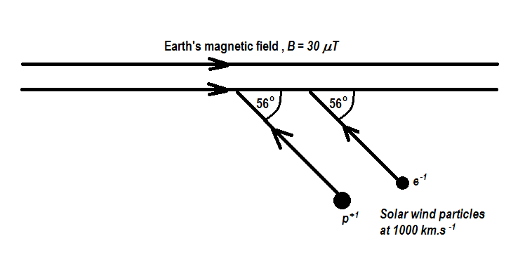

6. The visible spectrum has photons with wavelengths ranging between 400 nm and 800 nm. What is the minimum speed of a solar wind electron that excite atmospheric atoms so they are able to emit almost any colour in the visible spectrum? [4]

7. Explain how the charged particles from Io’s volcanic eruptions get captured and help produce the permanent aurora show on Jupiter. [4]

8. The energy levels in a hydrogen atom are given by the equation
$$E_{n}= -\frac{13.6 eV}{n^{2}} where n is an integer called a quantum number. \\ n=1 is the ground state and n= ∞ is ionisation$$
a) Draw an energy level diagram for a hydrogen atom showing the energies for
n = 1, 2, 3, 4, 5 and ∞. [7]

b) Assuming that hydrogen atoms on Saturn are excited with the ground state electrons transitioning to level n=5, list all the possible photon wavelengths that can be emitted when the electrons downward transition to level n = 2 as they de-excite. Show all working to obtain full marks. [6]

c) What is the minimum energy of a proton from the solar wind that can excite a hydrogen atom from ground state to the level n = 5? [3]
What will be the de Broglie wavelength of that proton? [3]

END OF TASK 7

